Tabletop Character Sheet Manager

# [Team Members]

* Jarrett Ruppert
* Jared Matthews
* Adam Stoltz

# [Project Description]

Tabletop Character Sheet Manager (TCSM) would, through a graphical user interface, allow the user to either (a) hand-pick and create a new character, (b) randomly generate, given generic race/level templates, a new character, and (c) edit/save character sheets to/from a file, for the purpose of tracking characters throughout a game of Pathfinder. TCSM would ensure that the rules of Pathfinder are not violated throughout the random generation or the manual generation.

# Part 1: Functional Requirments

## Manual Character Creation

* User dictates values of every field that makes up a character.
* App will validate that user input follows rules of the game.
* App will provide a set of default values with the option to customize.

## Random Character Creation by Template

* Prompts for name, level, race (preset list of races), and class (preset list).
* After generation, displays character and allows for any modifications (within Pathfinder rules).

## Data Persistence and Display

* Display a GUI for all operations, including character display.
* Define a file template to allow for loading/saving .txt files to view/edit characters.
* On startup, prompt user for filepath to directory with desired character sheets (allow for folder creation if it doesn’t yet exist).

# Part 2: Objective Coverage

* File I/O
* Inheritance and polymorphism
* Interfaces and abstract classes
* Enums

# Part 3: Basic Design

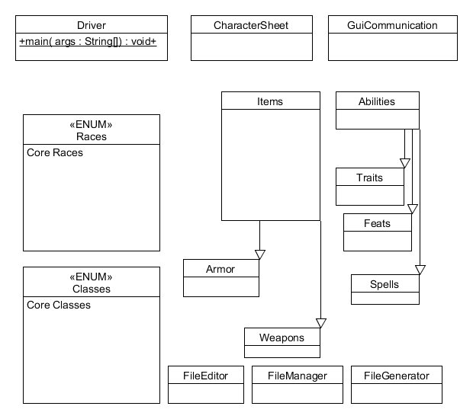

# Part 4: Project Plan

1. By Feb 24th, figure out game rules and logic needed to enforce it inside FileEditor.
2. Become competent in basic GUI’s with JavaFX – by Feb. 24th
3. By March 3rd, ensure FileGenerator and FileManager are functioning
4. By March 9th, finish touches on GUI and work out any remaining bugs